**use Lab4**

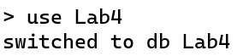

**db.createCollection("Data")**

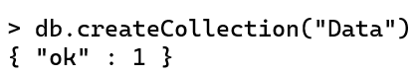

**mongoimport persons1.json -d Lab4 -c Data --jsonArray --drop**

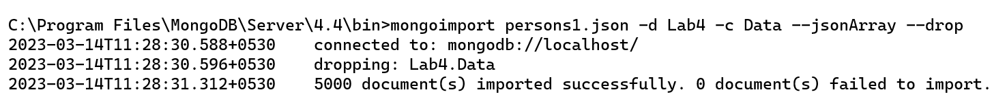

**db.Data.find()**

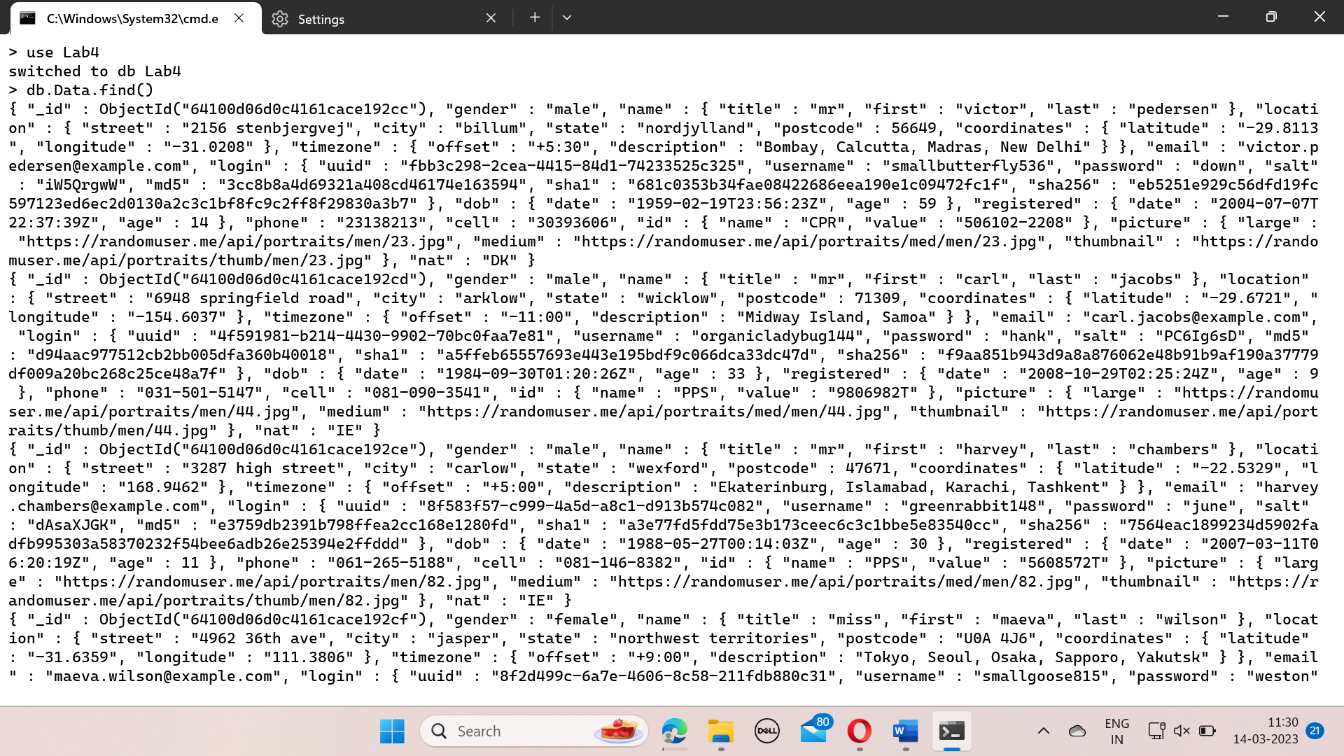

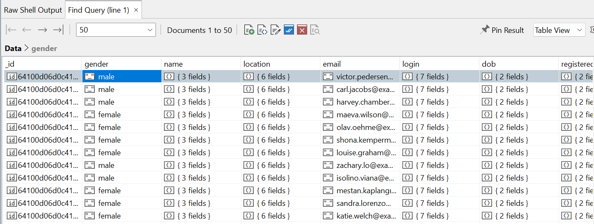

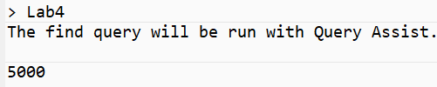

**db.Data.getIndexes()**

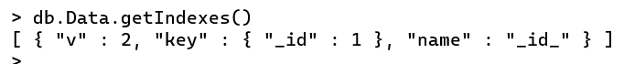

**db.Data.createIndex({age:1})**

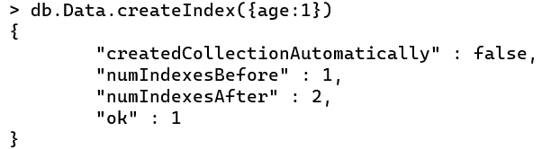

**db.Data.createIndex({name:1})**

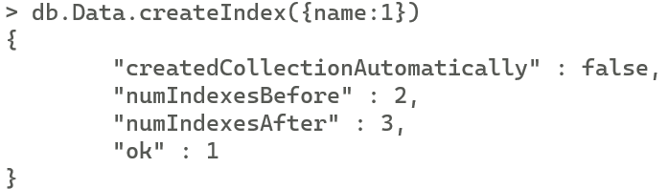

**db.Data.createIndex({index:1},{unique:true})**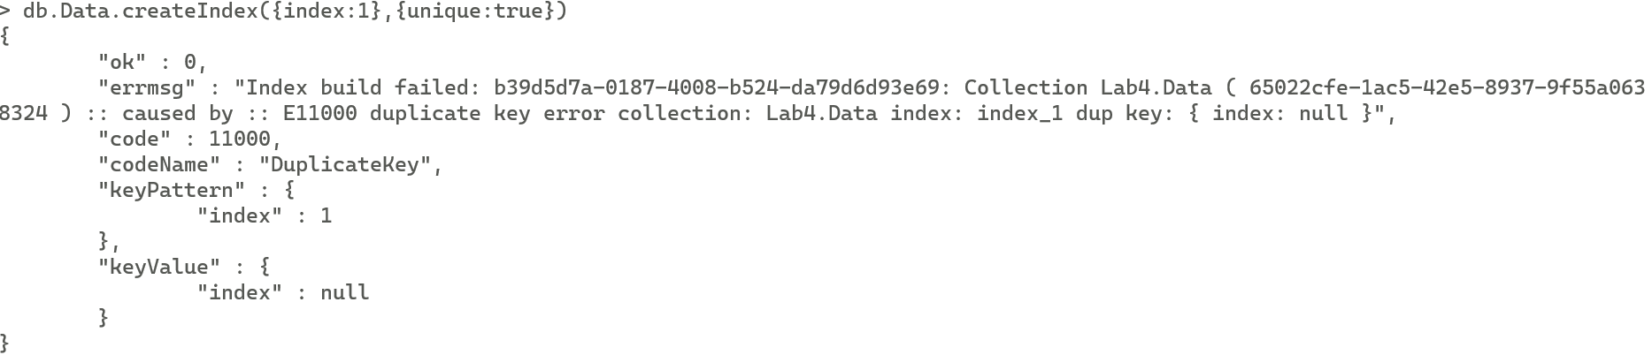

**db.Data.createIndex({name:1},{background:true})**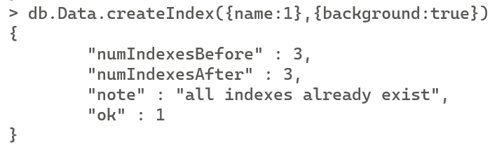

**db.Data.createIndex({age:1},{name:"customAgeIndex"})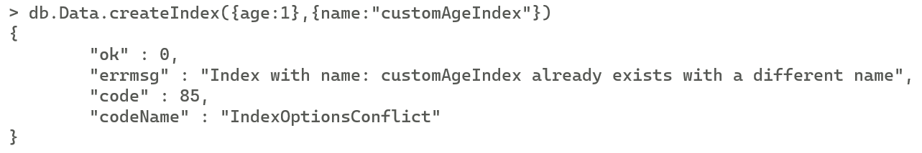 db.Data.explain().find({"Age":{$gt:25}})**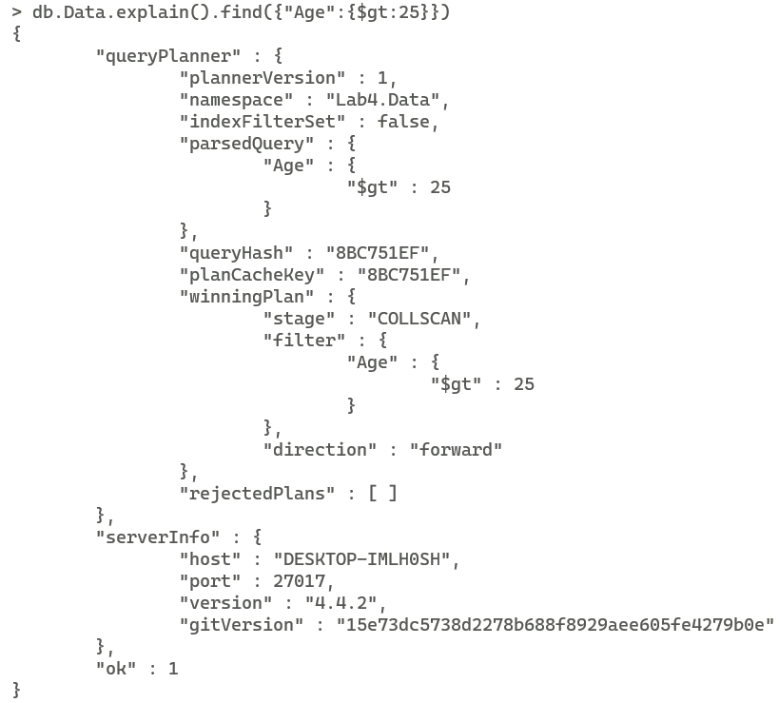

**db.Data.explain("executionStats").find({"Age":{$lt:25}})**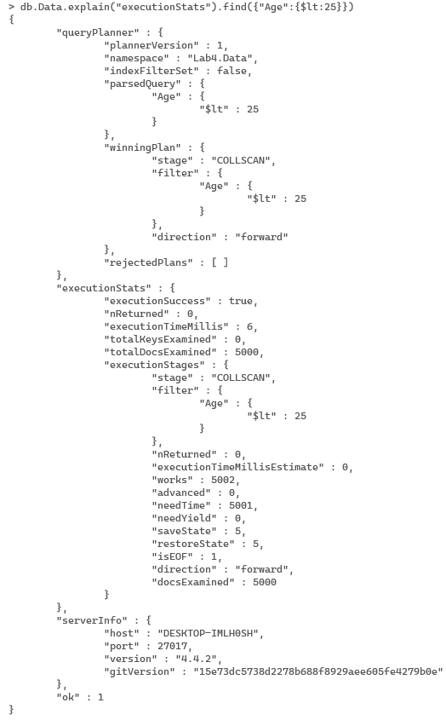

**db.Data.explain().find({"gender":"female"})**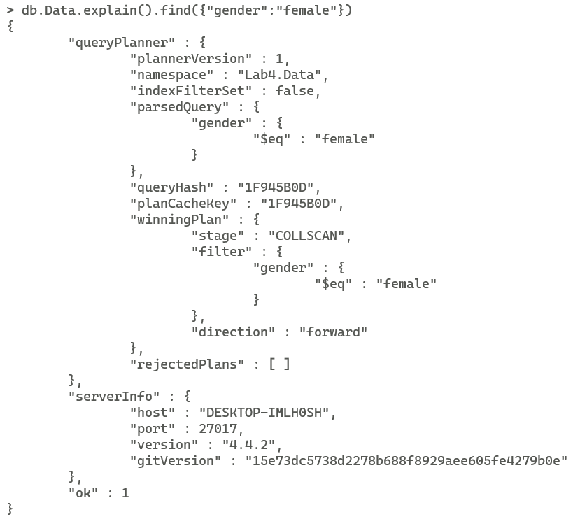

**db.Data.explain("executionStats").find({"gender":"male"})**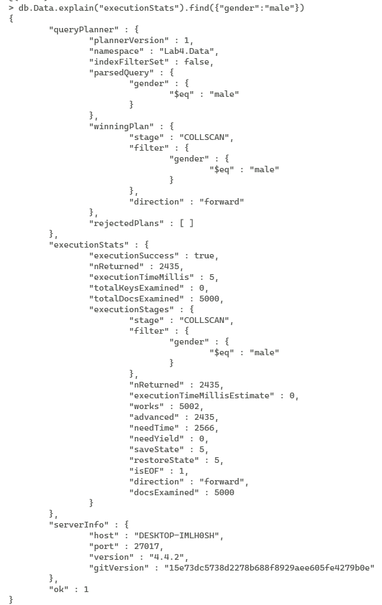

**db.Data.explain("executionStats").find({"name":/el/i})**